**Tiff to JPEG**

**Below Listed are few methods used to convert Tif/Tiff files to JPEG.**

**1.Using Single Tiff file to Jpeg:**

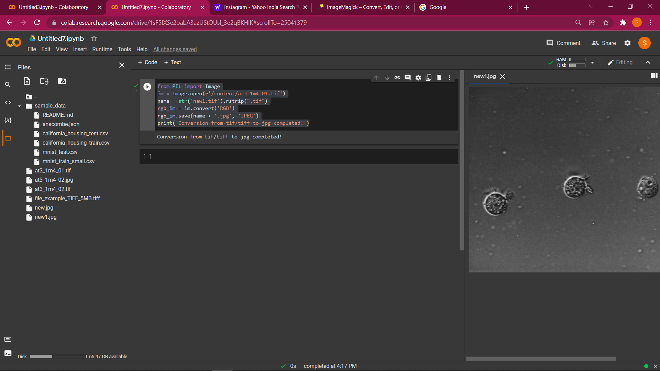

**2. Converting whole folder to JPEG (Issue with tiff files):**

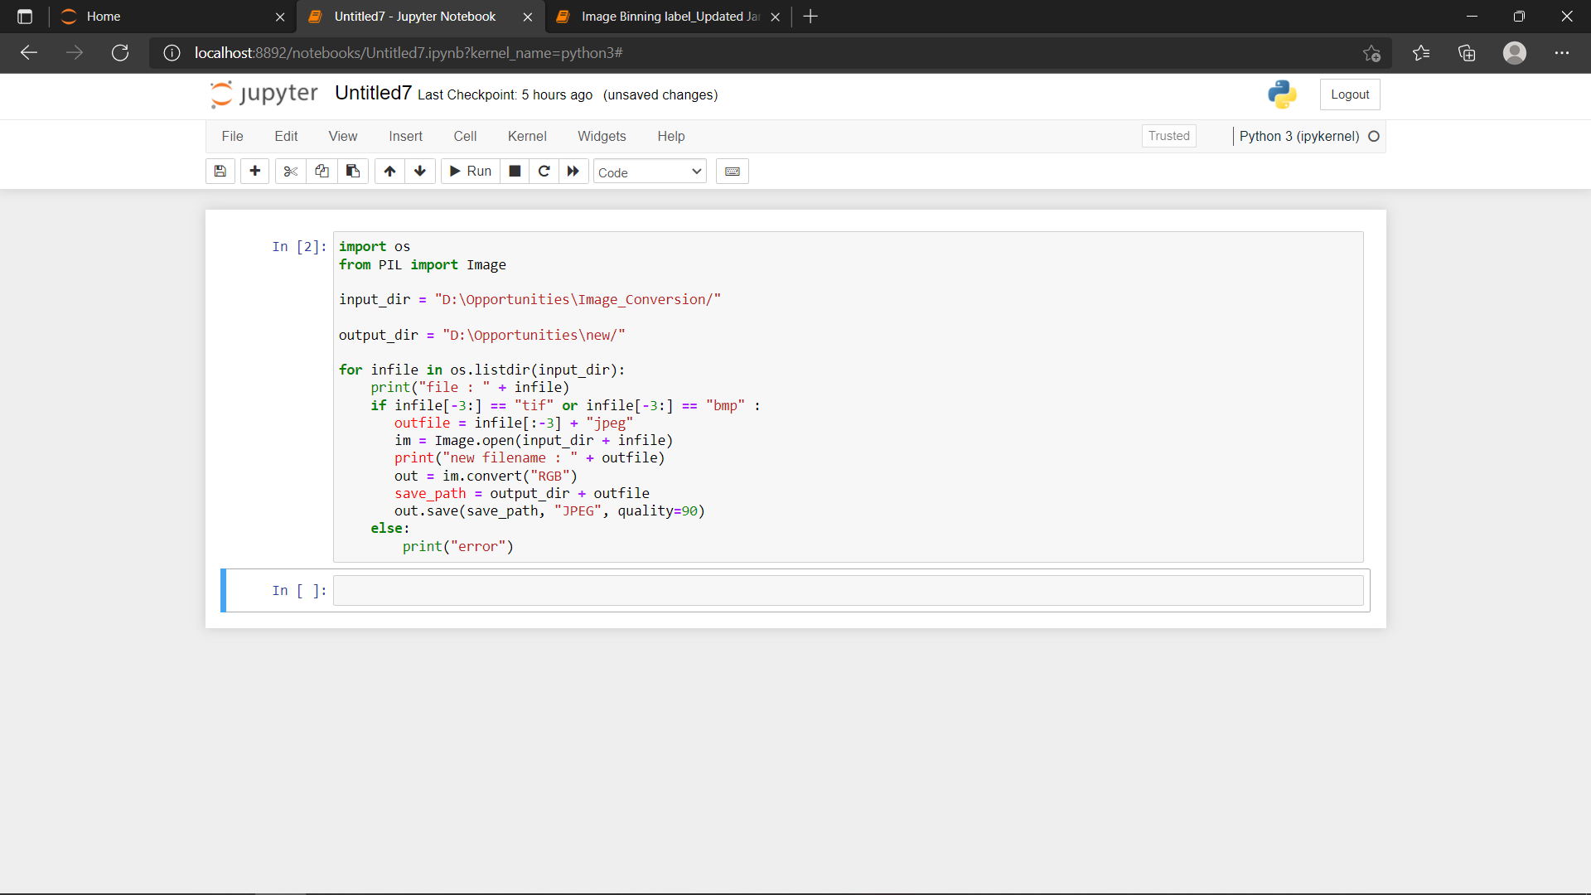

**3. Using online converters (Using** [**https://www.freeconvert.com/tiff-to-jpg**](https://www.freeconvert.com/tiff-to-jpg) **can convert multiple files up to 1GB at a time)**

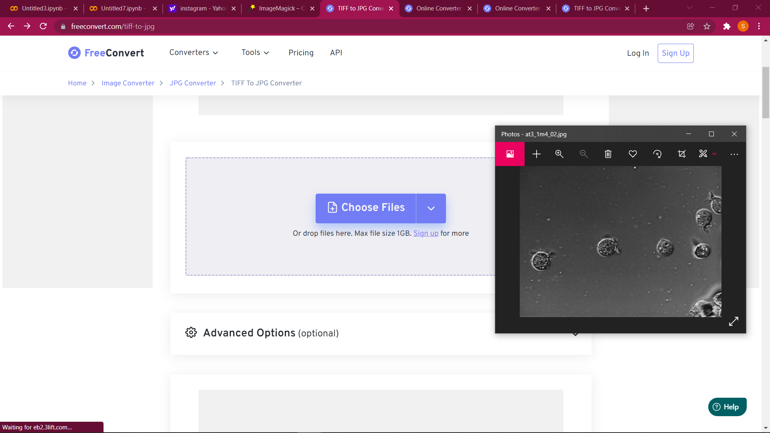

**4. Using specfic softwares to convert Tiff to Jpeg:**

